 

**SRI KRISHNA INSTITUTIONS**

**(AN AUTONOMOUS INSTITUTION)**

**(APPROVED BY AICTE AND AFFILIATED TO ANNA UNIVERSITY CHENNAI)**

**ACCREDITED BY NAAC WITH “A” GRADE**

**AUTOMOBILE SERVICING AND ASSISTS**

**AUTO-CARE**

**TEAM-40**

**TEAM MEMBERS:**

**RAJESH KRISHNA R**

**NANDHA KUMAR R P**

**VIVIN VENKATESHWARAN S**

**JAYASHREE RAVICHANDRAN**

**DINESH KUMAR V**

**ABSTRACT:**

**AUTO-CARE** is a window based application which provides the user with a convenient way to service their vehicles. It also provides ecommerce solutions for vehicles. The purpose of our project is to reduce the difficulties while servicing the vehicle.

The problem faced by many of us during the time of servicing our vehicle is self transportation. There are various solutions to resolve this problem such as providing the user with temporary vehicle, free pickup and drop facility. But we have several difficulties with these solutions as they are immoderate.

Our ultimate aim is to provide an efficient and authentic way by pre-booking the services of vehicles through our provided application. And also we came up with the new idea of an immediate assist through which the user can straight away access the service centre with no time.

We make things reliable and best for the users through our application.

**OBJECTIVES:**

1. To promote a user-friendly application.
2. To ensure the availability of the service time in prior by pre booking it in order to make ourselves opt to that particular time.
3. To provide independent and separate domains for user and admin.
4. To set simple and helpful access of the application in the desperate situation (i.e. breakdown other malfunctioning of vehicles etc.).
5. To provide transparency in selling goods (vehicle parts) online.

**EXISTING SYSTEMS:**

In the existing system, the user has problems in self transportation (i.e.) the user has to leave his vehicle for service in the service station and go back through other means of transport.

This entire process kills the time in which the user could have done something productive.

And maintaining data such as details of the dealers, purchases, sales details over a long period of time is quite difficult.

**PROPOSED SYSTEM:**

In this proposed system, the user can ensure the availability of the service time of vehicle in advance by pre-booking. So that the user can adhere to the service timing.

In a critical situation like malfunctioning of the vehicle, we have provided immediate assist functionality at any time with the necessary prerequisites.

This application has an e-commerce mode for buying spare parts online if required for the users.

Complete data storing and retrieving is achieved in this application which is 100% secure.

**MODULES:**

**1) SIGN-UP/LOGIN:**

This module is for the user as well as admin, admins being individual workshops.

**USER AND ADMIN REGISTRATION:**

Both the User and Admin have to register before they go about their business, every detail collected is sent to the respective database tables. And the other modules use them as they require. The only difference between user and admin registration is that the admins are individual workshops or Auto Mobile service shops.

**USER LOGIN:**

It is mandatory that user should enter the username and password before accessing the site. Entered data is checked in the database. If the user name matches the password then the entered data is correct. Then the user is allowed to access our booking site.

**ADMIN LOGIN:**

Admin is given an independent platform to monitor and authorize everything. Similar to the user login, admin is provided with the user name and password. It is then checked in the database and assures that the entered username and password matches the database. Once they get signed up, they can authorize the actions in the application.

**2) USER MODULE:**

The Entire User Module can be split into 4 distinct parts.

**APPOINTMENTS:**

The first is the deviant when it comes to the platform of Automobile Servicing, which is Booking an appointment based on your schedule with the whatever workshop the user chooses, just like Zomato or Uber Eats connects customers with a wide range of restaurants. Our database contains the details of all the workshops who have registered with our application.

The appointment will be Verified by the workshop and if a slot is free you are notified that you have an appointment fixed. You also have to choose the servicing mode, with that the employee of that particular workshop will be there on the appointment date to pick your vehicle and drop it back after fixing it up within the appointment time schedule.

If there are no appointment slot free on the precisely entered date and time by user, the user will be notified of that as well. The user can also cancel their appointment.

**ASSIST:**

The next important function is that, when a user gets into some kind of trouble, say like an engine bust, in the roadside, all he has to do is just load the application and request for backup, and this will choose the most closest workshop and sends the assist request, and based on the location of the workshop, an estimated time is put forth to the user.

**E-COMMERCE:**

You can also order spare parts that make up any automobile, and the order will again be delivered based on the location of yours and the location of the nearest workshop. If the nearest Workshop does not have the spare parts that you are in requirement of, the application chooses the next nearest workshop.

**VIEW HISTORY:**

The side segment is the functionality to view your entire history, be it the orders you do, the appointments or the assists that you took up in the entire time you have been a participant of our application.

You can also View your General Profile, edit it, with the inclusion of changing password.

**3) ADMIN PROFILE:**

Admin will be having thier unique ID's and Password taken up from the registration table and connected with the user as specified in the user module. Again, each Admin is actually a workshop.

After logging in,

**VIEW/UPDATE PROFILE DETAILS:**

Admin will be able to View all his Profile details. He will also be able to Edit/Update his location based on which he will be getting Appointments and Immediate Assist request.

**ACKNOWLEDGING THE IMMEDIATE ASSISTANCE FROM THE USER:**

Admin will be shown the table in which the details from the user Regarding Assistance is and

he will be able to do the Following:

* Accept the Assistance
* If accepted Estimate time to reach the user’s location will be sent to the User.
* Decline the Assist

**ACKNOWLEDGING THE BOKKING APPOINTMENTS FROM THE USER:**

Admin has the rights to view the appointments table,

He will be able to do the Following

Accept the Booking:

* If accepted a notification will be sent to User from Admin

Decline the Booking:

* If declined, the reason for Declining the user appointment will be sent to User.

**VIEW THE PARTS ORDERED AND RESPOND ACCORDINGLY:**

Table displaying the Details of parts Ordered with quantity will be shown to Admin

Admin will be responding ( response in the sense placed, in transit or delivered) to the user Until item delivery

Incase if user cancels the order, Admin will be updating those details to the Order Table

**GENERATE INVOICE:**

* Admin will be able to generate the Invoice of the Vehicle after the service is has a status of completion.
* He can view all the invoices generated and refresh the table to get added invoice.

Maintain All Customer Details:

* View All the customers and their details, also the admin can block certain customers.

Maintain the Delivery Details:

* A table will be displayed having the details of the vehicle whose work is done and is to be delivered.
* When Bill is Generated for a vehicle, that particular vehicle's detail will be moved to Delivery Table.

**DATA FLOW DIAGRAMS:**

FOR APPOINTMENTS AND ASSISTS:

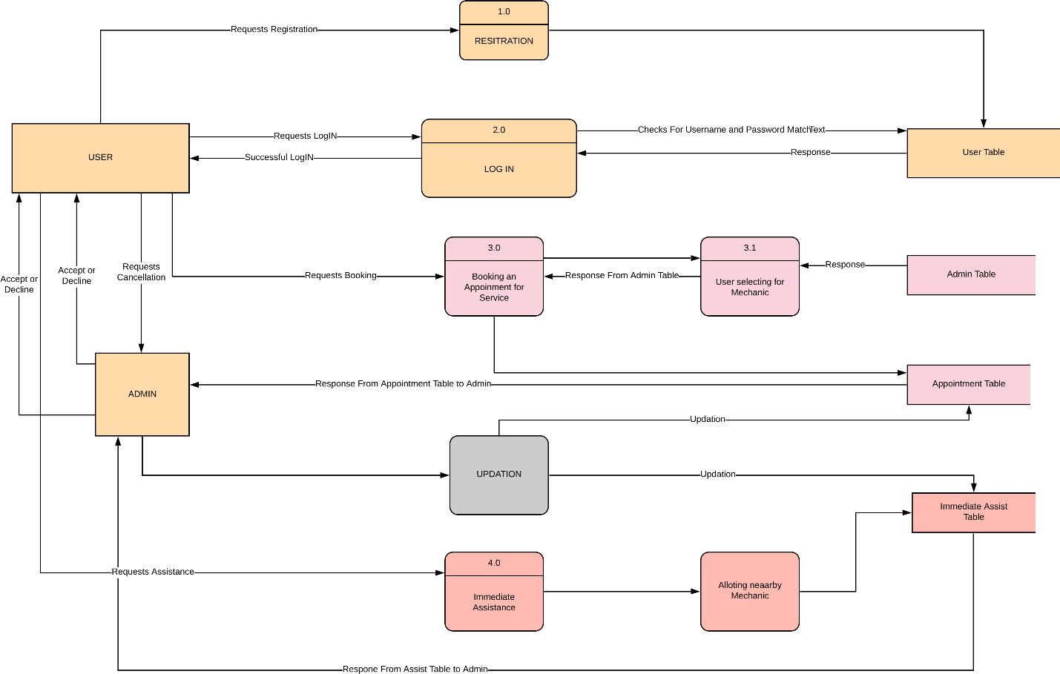

E-COMMERCE:

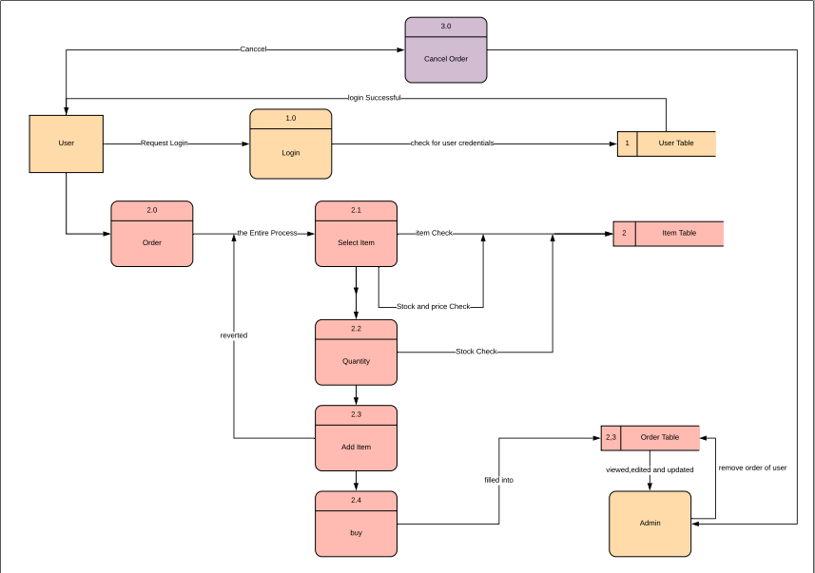

**DATABASE DESIGN:**

